AUTHOR GUIDELINES
This document provides author guidelines for writing papers for the Eleventh International Conference EEE 2022. Paper should be written in the same format in which this document is written. Please abide to the following instructions

TITLE OF THE PAPER
FONT TIMES NEW ROMAN 16 PT BOLD, ITALIC, SPACING BEFORE 30 PT, AFTER 30 PT, CENTER, FIRST LINE 0
(Primer stila Heading 1)
First Author
Second Author
Times New Roman TNR, Mala slova, 10 pt Italic, Spacing before 6 pt, after 6 pt, Center, First line 0,
Each author in separate line.
(Example of the style Autori)

ABSTRACT
(TITLES AND SUBTITLES STYLE)
TNR 14 PT, BOLD ITALIC, ALIGN LEFT SPACING BEFORE 24 PT, AFTER 24 PT, CENTER, FIRST LINE 0
(Example of the style Heading 3)
Abstract should be written according to the following instructions: Abstract should not be longer than 300 words, font TNR 11 points, italic, justified. Below abstract write the key words and JEL classification, as it is shown in this example.
(Example of the style Body Text)
Key words (TNR 11 pt. Bold, Italic): key word 1, key word 2, key word 3, key word 4, key word 5 (max. 5 TNR 11 pt.)
JEL Classification (TNR 11 pt. Bold): two-digit number (e.g. M26) (TNR 11 pt.) http://www.aeaweb.org/jel/jel_class_system.php
(Example of the style Body Text)

INTRODUCTION

All papers must not be less than one sheet of text (16 pages), (one page = 1,800 characters. The papers should be written in English, typed in Latin in MS Word (Times New Roman – TNR 11 pt. normal). All pages should be in B5 (ISO) format (20.1 cm x 27.6 cm). All margins (top, bottom, left and right) should be 2.3 cm. Text should be written in one column (not two or more) and in font Times New Roman, including the titles of pictures and tables, with single spacing [TNR, 11 point, normal, justified alignment, first line – 0.7 cm, spacing – before = 3pt, after = 3pt, line spacing – single, upper and lower case). The beginning of the paragraph should be written without using Tab or space.
(Example of the style Body Text)

Please note the additional instructions at the end of this document.

TABLE
All tables should be numbered starting with number 1. Title of the table should be written in TNR 11 pt. Italic, Spacing after 12 pt., after 12 pt., keep with next, above the table and centered. Tables should look like the following one:
Table 1. Title of the table
(Example of the style Tabela/Figura/Slika)
Kolona 1 | Kolona 2 | Kolona 3
Red 1 | Red 1 | Red 1
Red 2 | Red 2 | Red 2
Red 3 | Red 3 | Red 3
Source: Petrovići, 2005, str. 20-23
(Example of the Style Izvor)
Please do not bold the title and the number of the table.

PICTURES
All pictures should be numbered starting with number 1. The title of the picture should be written in TNR 11 pt., below the picture and centred. Please do not insert the text boxes above or below the picture. The picture should look like the following one:

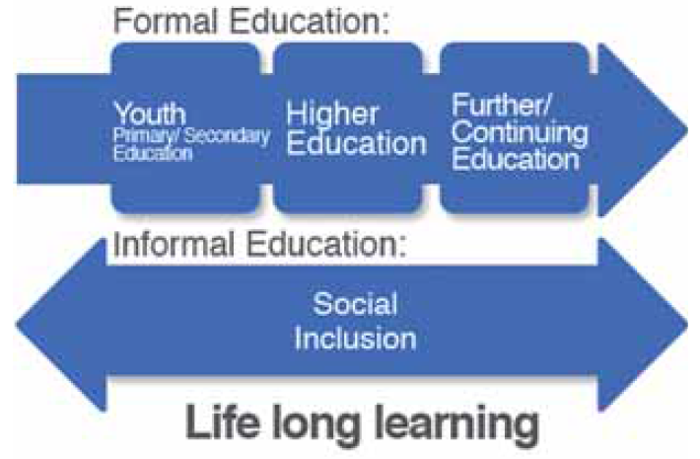
Picture 1. Title of the picture
(Example of Table/Figure/Picture)
Source: Primorac, 2005, pp. 20-23
(Example of the style Izvor)
Please do not bold the title and the number of the picture.

ENUMERATING IN THE TEXT
If you are enumerating in the text, please follow these instructions:
- Using bullets
- Move the text left 0.7 cm, hanging 0.3 cm, spacing before 6 pt, after 6 pt, Don’t add space between paragraphs of the same style.
- Use font Times New Roman (TNR) 11.
- (Example of the style Lista Bullet)
- Using numbers
- Turn off auto numbering, separate the number from the text by pressing TAB once, move the text left 0.7 cm, hanging 0.55 cm, spacing before 6 pt, after 6 pt, Don’t add space between paragraphs of the same style.
- Use font Times New Roman (TNR) 11
(Example of the style List Paragraph)

EQUATIONS
Equations should be 5mm from the left margin, and the ordinal number of the equation should have right alignment. Equations should be written in Times New Roman (TNR) 11 pt., and the ordinal numbers should be written in parenthesis TNR 11 pt, as it is shown. Use Microsoft Equation if possible.
(1)

CONCLUSION
Recommendations concerning page numbering, footnotes, headers etc: Please do not number the pages and do not use headers and footnotes.

REFERENCES
References in the text is stated in Harvard style (http://www.sciencebg.net/download/harvard-style-en.pdf). The list of references should be given at the very end of the paper, stating only titles that were quoted in the paper.
(Example of the style List Literatura)

ADDITIONAL INSTRUCTIONS
Dear associates,
In writing this document the following styles were used:
- Heading 1 – The title of the paper
- Heading 3 – All other titles and subtitles in the paper
- Authors – names of the authors
- Body Text – paragraphs
- Tabela/Figura/Slika – titles of tables, figures and pictures
- Izvor – sources of the tables, figures and pictures
- Lista Bullet – enumerating using bullets
- List Paragraph – enumerating using numbers
- List Literatura – enumerating the literature
While arranging your paper we recommend you to use one of the following three procedures:
- First option is to use the styles that were created in this document by using the option manage styles import/export and import the styles in your paper and allocate the appropriate styles to the appropriate parts of your paper (import is done from your paper)
- Second option is to save these instructions as a new document then erase the text and paste your paper, and then apply the styles that are already created here.
- Third option is to manually create and adjust the styles that already exist in your paper based on the data given in this document.

Institution, City, State, e-mail (TNR 9 pt.)
Institution, City, State, e-mail (TNR 9 pt.)

